Practical No. 6
Aim : ALP for Subtraction of two 8-bit BCD numbers
Name : Danish Altaf Solkar Class : CO - B
Enrolment no. : 24111590805 Batch : 2
Code :-
assume cs:code
assume ds:data
data segment
a DB 53H
b DB 28H
res DB ?
data ends
code segment
start:
MOV AX,data
MOV DS,AX
MOV AX,0000H
MOV AL,a
MOV BL,b
SUB AL,BL
DAS
MOV res,AL
INT 03H
code ends
end start
OUTPUT :-
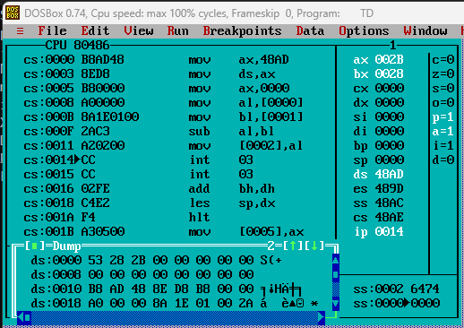
Before using DAS
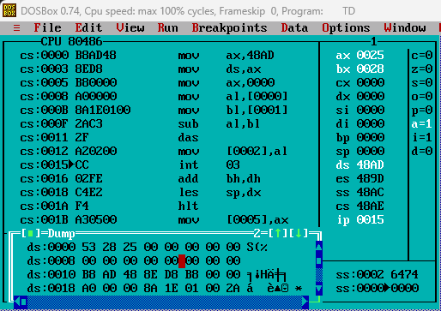
After using DAS

Process related  (15) | Product related  (10) | Total Marks  (25) | Signature

